Project Development Phase
Model Performance Test

Date | 21 February 2025
Team ID | SWTID-2026-6670
Project Name | Implement Client Script & UI Policy (Incident)
Maximum Marks

Model Performance Testing:
Project team shall fill the following information in model performance testing template.
S.No. | Parameter | Values | Screenshot
 | Model Summary | ServiceNow validation automation setup for Incident data management using a UI Policy, UI Policy Actions and Client Scripts.  Note: If the incident data meets the rules, the record is saved; otherwise an error message is shown and the save is blocked. | 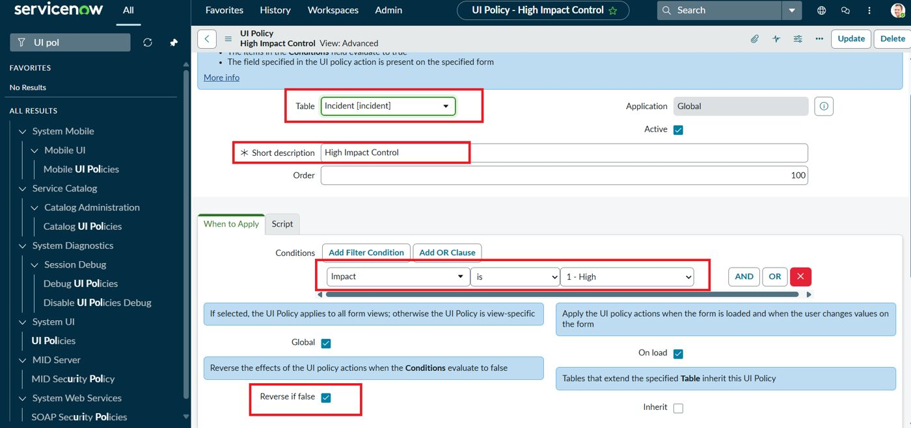
 | Accuracy | Training Accuracy - Not applicable (no trained model)  Validation Accuracy - 100% (9 of 9 test cases passed) | 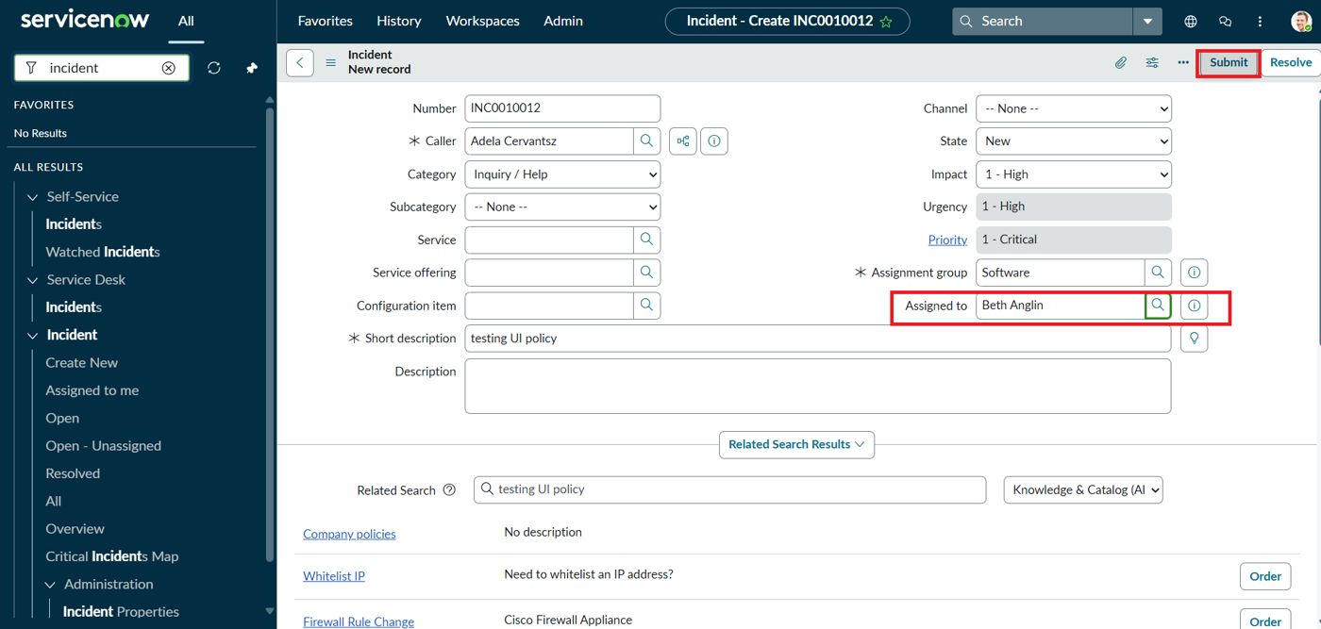
3. | Confidence Score (Only Yolo Projects) | Not applicable (not a YOLO / object-detection project).  Validation outcomes shown instead: an error message blocks a High-impact save without Assigned To, and an alert blocks State edits in the list view. | 